Undergraduate Portfolio System

Project Proposal - V1-

April 2013

Team Members

Tim Westbaker

Sam Foster

John Sullivan

Adrien Rahier

Patric Skigen

Mike Botieri

Philip Kolmar

Ben CarlsonDocument To Do

Audiences

* Review Audience

Technical Approach

* Coding Standards

Solution Overview

* Proposed solution
* Add more details to in scope and convert to paragraph
* Alternative solutions
* Design approach

Designs

* Site map
* User flow charts
* Wireframes
* Storyboards
* Database schema

Abstract:

This document is intended to clarify the specifications of version 1 for the portfolio system. In this first version of the project we will only tackle some parts of the problem. You will find in the featured section all the functionalities that we should implement. For a more general overview of the project refer to the main document.

**Questions:**

Overarching questions that need to be explored further to continue conceptualizing and designing the Portfolio System

1. Who uses the system?
2. What does work look like?
3. How do you find/discover work?
4. How do we test the system? > (user testing?)

List of the features of the V1:

This section describes what features are available to which audiences. Note that students, faculty, and members all have access to anonymous features and students and faculty have access to member features.

Anonymous User Features

* Browse student work in collections
* View student profiles
* Search for students, work
* Register account

Member Features

In V1 of the portfolio system, there would only one type of member.

* Create profile
* Upload/edit/publish work
* Comment and rate work
* Provide feedback on work
* Discover/browse/view work and profiles
* Manage account
* Be able to send direct message to student (potential collaboration, lab/job opportunities, other)
* Communicate with the users
* Provide feedback about the site
* Organize/contextualize and archive work
* Share work and work-in-progress
* Delete account & data

Detailed features

This section organizes system features into common feature groups and further explains what the feature is.

**Account**

* Register new account

Creates a new member, student, or faculty member

* Delete account and data

Removes all data and account information

* Manage notification settings

Set notification methods (email, text) and notification types to receive

**Profile**

Profiles are available to any logged in user, however, different user types have different profile information. See Definitions > User Profiles in the main document for specific differences.

* Update profile information

Change profile information such as description, interests, etc.

* View profile

View any user’s profile information

**Student Work**

* Create new work
* Organize and contextualize work
* Designate work as in-progress or complete
* Add questions about the work that the user specifies

**Browsing/ Discovering Work**

When a user wants to discover new work we defined these three cases:

1- The user is searching for something specific: a particular student, class, faculty member, portfolio, etc. (best facilitated via search and filter features: directly get to where you need to go)

2- To browse, to discover new work based on particular criteria: browsing by categories, departments, groups, etc.

3- The 'discover' mode, where a user can meander through, and how does this work, based on associated/suggested/related work, random projects, etc. Mike suggested Netflix as a comparison, how they generate suggested movies to you...

Browsing and navigating the Portfolio system is a core function of Portfolio System vI. We have identified three models for browsing work and the strategies for each.

1. **Direct Navigation –** A user needs to get to something specific: a particular student, class, faculty member, project, etc. This is best facilitated via search and filter features that allow the user to get directly to where they need to go.

**Strategies**:

* 1. General search bar at the top of all pages – searches for everything: keywords, names, categories, projects, classes, tags, etc.
  2. Advanced search/Filters – allows user to define specific parameters and limit search/navigation by any available contexts: department, class, faculty, category, term, etc.

**Specific fields for search/filter/advanced search:**

* Search – Basic search bar that is featured on all main pages. Returns both Profiles and Projects. Search function queries the following items
  + Students – returns student profile and associated projects
  + Faculty – returns faculty profile and associated students/projects
  + Project name
  + Portfolio name
  + Keywords – department, class, category
* Filter – Advanced Search page, allows user to filter for profiles and projects by:

Department (Major)

* + Class
  + Category
  + Rating (projects only – not profiles)
  + Time/Recent (projects only)
  + Most Viewed (projects only)
  + Academic Interests – (required field on student profile)

1. **Intentional Browsing** – A user is looking to discover new work based on specific parameters: To find work in a department, or a certain category, or associated with a faculty member. Assumably, this is the primary navigation strategy of the site, allowing for simple and efficient browsing to all work within the system.

**Strategies:**

* 1. Top navigation bar menu items allow the user multiple entry points to navigate into work: Department, People, Categories, Groups(?).
  2. Dynamic sidebar informs user of location within the site, and allows for further navigation or refinement of browsing (e.g., Dept. view allows user to drill down to individual faculty or class level.
  3. A ‘Recently Visited’ list of pages functions as a convenient reference for the user, easily allowing them to step backward to any recently viewed pages.

1. **Discovery –** This mode suggests related and recommended content to the user based on the page they are currently on and the work they have been viewing. More than a single mechanism, this mode is a collection of strategies which offers the user a non-linear ‘discovery’ mode of browsing, in which new content can be continually generated based on the user’s activity.

**Strategies:**

* 1. Right-hand side of screen is a vertical list of work (projects/profiles/portfolios?) under the heading “Recommended to you…” that is generated and continually updated by:
* Matching project and profile metadata: department, class, term, faculty, category, sub-category. (Exact list TBD, based on profile and project features)
* Associated faculty and collaborators
* Work with many of the same tags as current page
  1. On a project view, contextual data can be clicked on to link to that page. For example a project that has “New Media” listed as department can click on New Media and go to projects in New Media, or clicking on the Category or Sub-Category listed will bring you to projects of that kind.
  2. If tagging is implemented on individual projects and/or profiles, the tags can be clicked to link to work with the same tag(s).

1. Intelligent “Recommended work” content, based on users cumulative activity on the site: a history of the work that they have viewed, their own personal work, connections and tags, and in the future if a rating system is implemented, similar content to work that user has rated highly:

Suggested – profiles and projects, based on:

* 1. User interests
  2. User departments
  3. User-related projects
  4. Viewed profiles
  5. Viewed projects
  6. Bookmarked projects

* User controls:

* “Suggested to you because you liked/viewed/are interested in/etc….”
* User can delete associations and suggestions to build up suggestion profile over time

Ultimately, all three navigation models are intended to work together, with each available at any given time and at all stages within the site structure.

**Additional/Extended Features and Ideas**

1. “Random” Tab: Additional tab on top navigation bar to take you to:
   1. Random Project
   2. Random Portfolio
   3. Random Profile
   4. Random Group (if implemented in v1)

**** To discuss / rearranged...

**Interacting with Work** – Features available to registered members only, except where noted.

* Profiles:
  + View (available to anyone)
  + Send message (through email)
  + Bookmark work
  + Share permalink
* Projects:
  + View (available to anyone)
  + Comment
  + Message owner (through email)
  + Bookmark within the site
  + Share
    - Permalink
* “Like” or otherwise link to social media

The toolbar:

... to be continued

**Comments (feedback on user work):**

* Within the project, the user would be able to message the owner directly through email
* The owner would be required to select a question (or questions) about their project that they would like answered
  + There would be a pre-generated list of questions that the user could choose from, or they could make their own questions. The owner could also disable comments for their project
  + The questions could be contextualized by the owner, allowing the question to be linked to a specific part of the project (a picture, certain pages of a paper, a section of a video, etc)
  + The questions would function as “threads” that the owner could close when they have received the answers that they were looking for, and then they could create new question threads if they wanted to get a different set of comments
  + Closed threads would remain, but would be grayed out and/or say “thread closed” and would collapse into just the question (a button would expand closed threads so that the comments could be read)
  + The owner would only be able have a certain number of threads open at a time.
  + Comments would have a required number of characters to be posted

**Feedback (about the Portfolio System):**

* The portfolio system should have some form of “Contact Us” section that might contain a forum and a way to message the development team
* Within the “Contact Us” page, there would be an “About” section that would describe the portfolio system (and ASAP?)

Site Map

* list the different path for a user to find work/student

**Anonymous User Sitemap**

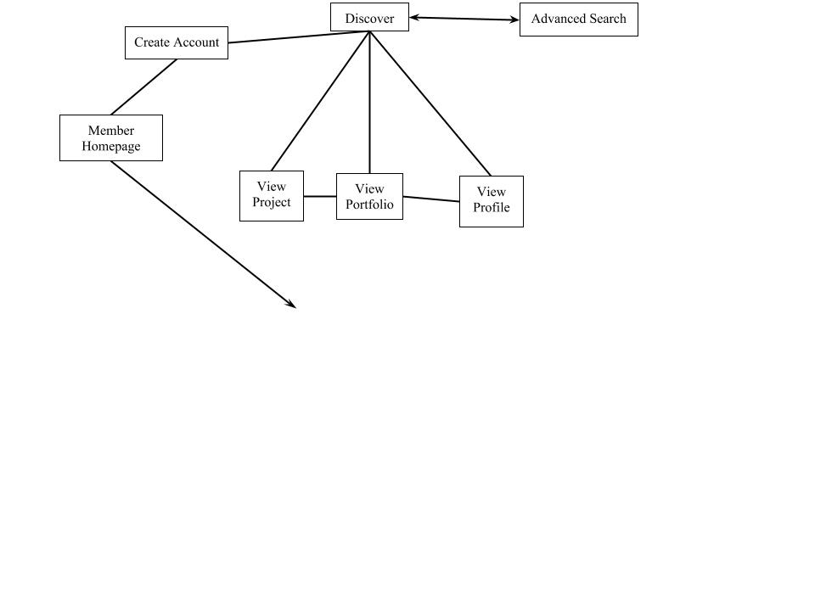

**Member Sitemap**

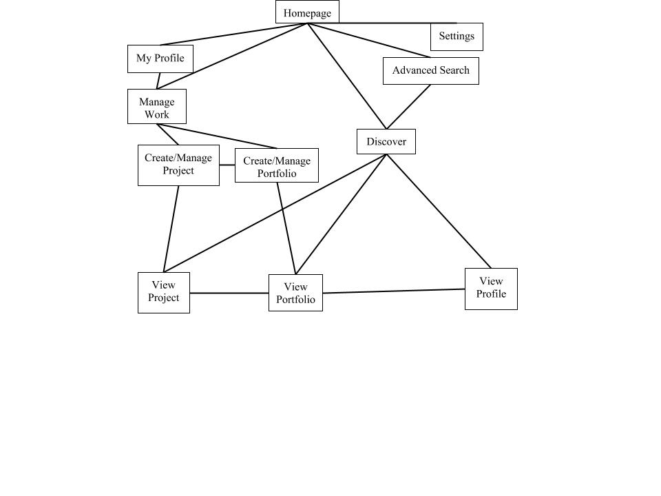

**Sitemap Pages:**

**Homepage:**

The initial page that a member (signed-in user) would see when they visit the site (or when the sign-in). There would be work displayed on the homepage in some capacity, which would reflect the users history and profile (comments, bookmarks, interests, etc)

**Create/(edit?) Account:**

An easy to find link on the homepage should take you to a page where an anonymous user would create an account and set up their profile (or a signed in user would be able to edit their profile). Once the account is created, it would the user to their profile.

**My Profile:**

From the homepage (if logged-in) the user would be able to access their profile page which would show information about them as defined when they create their account (name, profile picture, year, major, dept, interests, an about section, etc). The page would also display a section with the users work (upon the first time visiting their profile, it might prompt the user to create a portfolio)

**Manage Work:**

The manage work page would show a user’s portfolios and projects and allow easy access to editing them. Members would be able to access this from the homepage or from a section on their profile page

For the purposes of Projects the word “context” includes:

* Who it belongs to
* Description and purpose
* Department
* Collaborators
* Categorization of some kind
* Term: start date and end date

**Create/Manage Project:**

This would allow the user to upload media, format the media, put media together, arrange them as needed, add text in-line, and add context

**Create/Manage Portfolio:**

This would allow the user to put projects together and add context

**View Profile:**

Every profile would be viewable on its own, it would show all the public information about the user whose profile it was, as well as a section of their work where other users could see any work that they have access to. There would be some way to message the owner of the profile here as well. The user would be able to go directly to that work by clicking a link in the profile’s work section.

**View Portfolio:**

Every portfolio that the user has access to would be viewable on its own, either through browsing or by selecting it on the profile page that it is associated with. This would display the portfolio along with its context. The user would be able to click on projects within the portfolio and view them independently.

**View Project:**

Every project that the user has access to would be viewable on its own, either through browsing or by selecting it in the portfolio that it is associated with. This would display the project along with its context, and potentially a feedback section

**Discover:**

**This page would allow the user to browse work/profiles. Upon first visiting the page, the user would see all the projects in the portfolio system. It would have a method to explore departments, categories, classes and any other fields deemed appropriate: each field would have a drop-down list of all members of that field (a list of departments in the department field, etc). The lists would be organized so that the user could easily sort through them (organize alphabetically, organize departments by college, classes by department, etc). Exploring a field would change what work is displayed on the discovery page to only show work in that field. The discover page would also be the anonymous user homepage.**

**Advanced Search:**

A page that would provide a search function as well as many filters (as listed in the browsing/navigation features section). Upon validating the search, it would take the user to a browsing page with filtered results

**Settings:**

Where the user would change their preferences for the site and edit their profile

**Browse:**

The browse page would show the user work and profiles that would filtered through a variety of methods depending on how the user began browsing (they might use the filters in advanced search, or begin browsing through a hierarchy like department>class>browse).

User Flow Charts

Wireframes

* homepage
* profile
* discovering work
* creating new project from A to Z
* registering and connexion page
* managing portfolio work
* Toolbar

Storyboards

Class Diagram

Database Schema

Features for future versions

The features that we would like to include, but that are not yet necessary for the portfolio system

Anonymous User Features

* Flag content as inappropriate
* Like with Facebook, G+, social network

Member Features

* System suggests students with similar/complementary interests
* Suggest students/work to other users

- The user could be able to control who is able to provide feedback

* this could control different levels of feedback, i.e.:
  + Only certain users could leave comments/feedback

Faculty profiles should be implemented in a later version of the portfolio system

Browsing/Navigation

Featured – On main browsing pages (homepage) do we keep it?

Top – returns highest rated projects

Hot – Highest rated in last <timeframe>

Recent – Recently added

Popular – Most viewed in last <timeframe>

Interaction with Work

Profiles:

* + Follow
  + Share –
    - To other members
    - To Facebook, Google+, etc.
    - Permalink (available to anyone)

Public Projects:

* + Share
    - To other members
    - To Facebook, Google+, etc.
  + “Like”/Rate – “like” and share might be the same for external social networks
    - should these be separated into two separate available functions, or just keeping one or the other?
    - Like = Thumbs up, ‘appreciate’,
    - Rate = Scoring system: 1-5 stars, grading, etc.
    - ... To be discussed
  + Rate
  + Flag as inappropriate